Khan Academy Balance of Payment Questions
- Which of the following will occur in the balance of payments if Wakanda begins to export more than it imports?
- The financial account will move to a surplus
- The current account will equal zero
- The current account will move to a deficit
- The current account will move to a surplus
- It will experience a financial account balance
- Which of the following best describes the balance of payments accounts?
- A record of all international transactions
- A record of all of a country’s exports and imports
- A record of the financial capital inflows and outflows in a country
- A record of a bank’s assets and liabilities
- A record of foreign remittances to a country
- Which of the following statements about the financial account is true?
- Imports create a financial account credit
- Exports create a financial account debit
- Remittances (cash transfers) create a financial account debit
- Funds coming into a country are debits to the account, funds leaving the country are credits to the account.
- It can be balanced, show a surplus, or show a deficit
- Which of the following describes something that would definitely be recorded as an increase in the current account?
- An increase in real GDP
- A decrease in factor income earned abroad
- Selling bonds domestically
- Selling bonds to foreign citizens
- An increase in net exports
- Mr. Frank is a citizen of Gatorland. He wants a better return on his savings than he gets in Gatorland, so he buys newly issued government bonds from the nation of Hamsterville.
- How is this purchase counted in the balance of payments in each country?
- A debit in Gatorland’s current account; a credit in Hamsterville current account.
- A credit in Gatorland ’s financial account; a debit in Hamsterville financial account.
- A debit in Gatorland’s current account; a credit in Hamsterville current account.
- No impact on Gatorland’s balance of payments; a credit in Hamsterville current account.
- A debit in Gatorland’s financial account; a credit in Hamsterville's financial account.
- Which of the following would NOT be included in the current account of Wakanda?
- Remittances from workers in Wizbaland sent back to family members in Wakanda
- Factor income earned by citizens of Wakanda on real assets held in the nation of Housego
- Imports to Wakanda from Hamsterville
- The nation of Maxistan buys a bond from Wakanda
- Exports from Wakanda to the nation of Theopolis
- Which of the following represents the balance of payments?
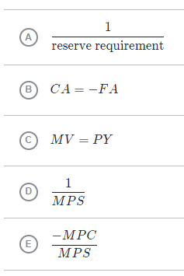​

Answers
1 | D | 6 | D
2 | A | 7 | B
3 | E | 8
4 | E | 9
5 | F | 10

